A SAMPLE ABSTRACT FOR ICTT-28

**First Author**

First Author Address, line 1

First Author Address, line 2

first.author@email.com

**Other Author**

Other Author Address, line 1

Other Author Address, line 2

other.author@anotheremail.edu

In this work, we will examine the Boltzmann equation:

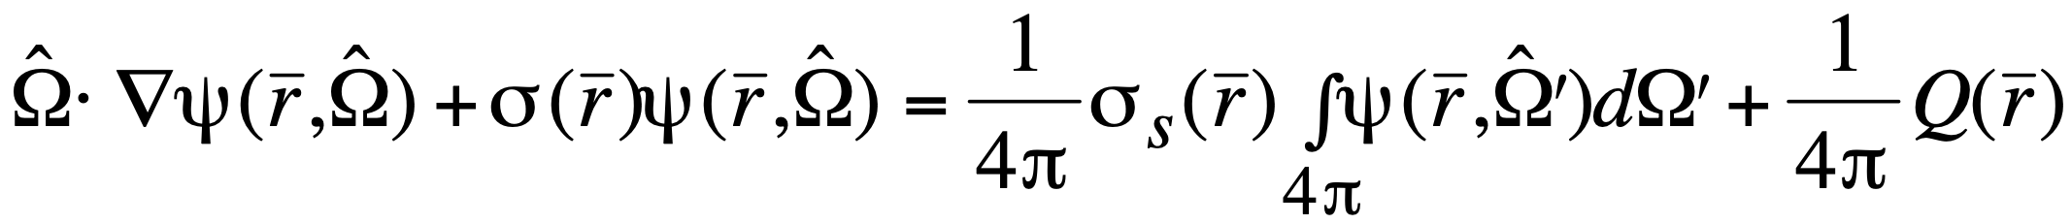 (1)

**ACKNOWLEDGMENTS**

The authors express their gratitude to their Institution.

**REFERENCES**

[1] G. C. Pomraning, *Linear Kinetic Theory and Particle Transport in Stochastic Mixtures*, World Scientific Publishing, River Edge, New Jersey USA (1991).

[2] R. Sanchez, Ann. Nucl. Energy **35**, 446-457 (2008).